# Colour Theory Research for Better TrailSeek

Colour accounts for an innumerable part of the success of any given App. The right use of color, or the wrong use of it, could be the defining factor for whether users download/look over your app in the store, enjoy your app, or delete it after one use. The same also applies to product branding.

Colour works in cohesion with iconography, typography, and an overall optimized UX to achieve optimal results.

We all know Humans are creatures of emotion. Colors subconsciously evoke different emotions in people. Our target is to choose a color that best evokes the emotion desired in its target market in order to facilitate a deeper connection with the TrailSeek.

After a research on color theory it has been concluded that Colors not only improve the visual appearance of Trailseek app, but also improve its UX by aiding in navigation.

The state of mind induced by the different colors affects how users interact with Trailseek. This could translate to whether or not they convert into permanent users of the App.

U**nderstanding the psychology of color**, in order to leverage it to best suit the purpose of your mobile application is very important.

some of the most used colours are

They are split into 3 categories: primary, secondary and tertiary colors.

<https://www.usability.gov/how-to-and-tools/methods/color-basics.html>

A sample of colors and the emotions affiliated with them.

The modern person uses a tech/non-tech product every day.

Here’s how some of popular products are applying the principles of color psychology.

As you can see from the image above, the color spectrum is split almost in half. This separates the bright colors (also known as the warm colors), and the darker colors (also known as the cool colors).

You may also have noticed that e-commerce sites (think Amazon, Alibaba, Jumia), retailers, and various consumer brands tend to go with the warmer colors. This is because the colors on this end of the spectrum evoke feelings of happiness and energy, and subconsciously make the user more likely to make a purchase.

Numerous social media platforms also go with warmer colors that set a bright and cheerful mood on their platform. Think Snapchat’s yellow and Instagram’s vibrant mix of pink and yellow (evident in the logo).

Financial service firms like banks (think Barclays/ ABSA’s former branding, VISA ), and tech companies (think Twitter, LinkedIn, Facebook), more often than not go with the cooler colors. Blue is especially popular with this category of brands, as they seek to evoke the feeling of calm and trust in their user base.

On the far end of the cool spectrum is grey — black, which luxury brands absolutely love to use. Think top fashion brands like Calvin Klein, and luxury tech products like Apple.

In the early days of Uber, it was marketed as a premium black car service, hence the black and white branding that it has stuck with to date. You can check out Uber’s very first pitchdeck explaining its initial concept and value proposition.

Some colors sit right at the edge of warm and cool. One such color is green. Green is very often selected to represent brands that want to communicate a natural feel to their clientele. Agricultural brands (think farm machine manufacturer — John Deere) and organic lifestyle product brands (soaps, body oils) typically use this color.

Now, color psychology is by no means a precise science. Colors are not the only elements of good design that result in paying customers. Context, culture and numerous other factors come into play. However, these are the subject matter for a whole other article.

With this in mind, how about taking another look at your app before publishing it on the store for your users to get a hold of.

## **Mobile App Design:Trendy Color Schemes**

Mobile app design is vital for any business today if it aims to provide excellent user experience. According to studies, users spend 89% of their smartphone media time in mobile apps. That’s huge! Moreover, more than 50% of people wake up and start using their mobile phones immediately. This knowledge dramatically increases the importance of a mobile app design.

An essential part of the mobile app design is color scheme. One simply can’t underestimate the power of color in apps. Right color scheme helps not only set the mood for your app, so users could interpret it they way you want them to. It also assists users to interact with certain elements and understand important actions within the app.

When making a decision about a color scheme and primary colors in the app designers can go two ways: traditional and custom color palettes. Traditional color schemes include analogous, monochromatic, triad, complementary and compound. Custom color schemes are ever-evolving field for experiments though. The main challenge is to select the color scheme, which is trendy enough and at the same time effectively supports mobile app usability.

What’s common for every color scheme is the color wheel. By combining colors of the color wheel designers build a distinctive color scheme and thus achieve a certain effect. Let’s look at 14 trendy color schemes that designers successfully use:

Mobile App Design: Analogous Scheme

Mobile App Design: Monochromatic Scheme

Mobile App Design: Triadic Scheme

Mobile App Design: Complementary Colors Scheme

Mobile App Design: Compound color scheme

Mobile App Design: Color Shades

Mobile App Design: Custom Color Scheme

Mobile App Design: Colorful illustrations

Mobile App Design: Colorful Gradients

Mobile App Design: Black & Shades

Mobile App Design: Pastel colors

Mobile App Design: Bright Icons

Mobile App Design: Subtle Shadows

Mobile App Design: High-Contrast Colors

# What is Colour Psychology?

To answer that question in depth we would be here for hours, but in a nutshell, colour psychology is the study of colours and how they can influence human behaviour. There are four primary psychological colours – blue, green, yellow and red. Each relates respectively to the mind, the body, the emotions and the harmony that exists between these elements. When mixed to create secondary colours, these four primary colours become eleven that can be harnessed to generate specific behaviour in humans.

The Eleven Colours and The Psychology Behind Them

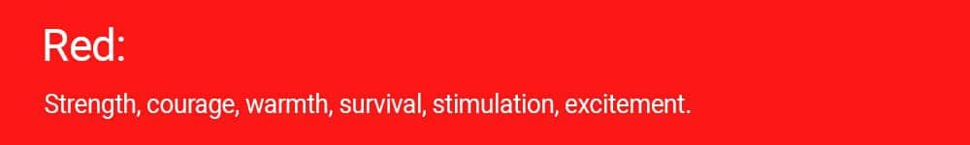

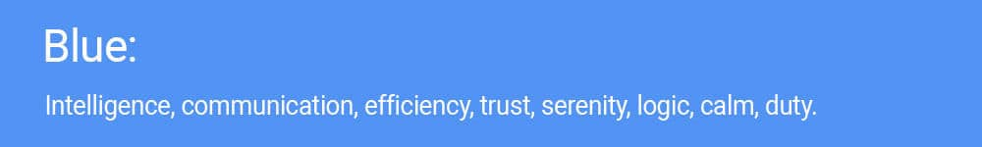

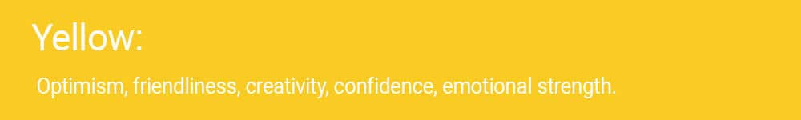



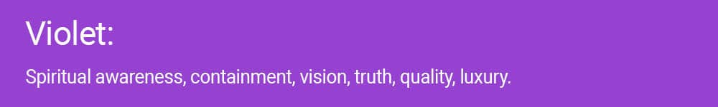

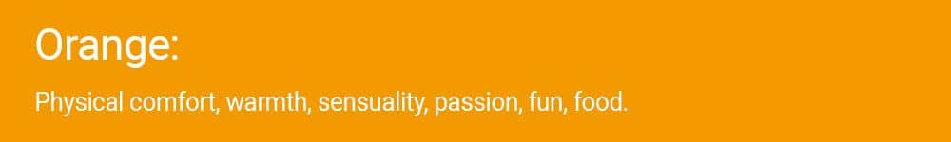

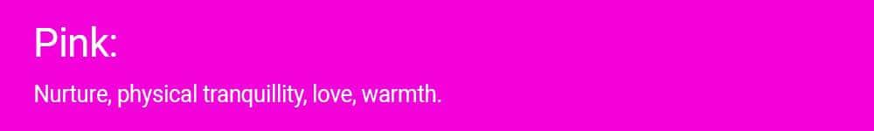

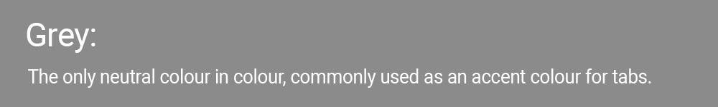

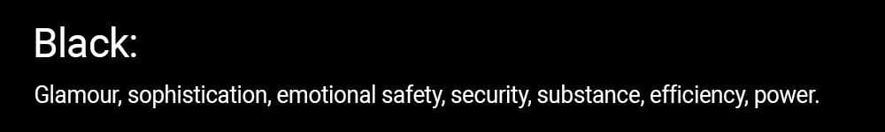



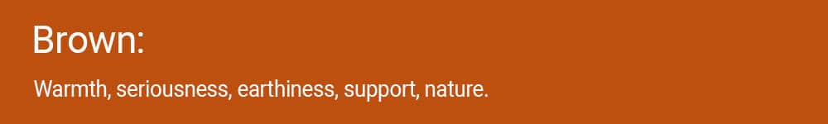

## Finding the Right Colour Scheme For Your App

When there are infinite possible colour schemes available to you, it can be difficult to decide on the one that will work best for your app. Not only will that colour dictate how your app looks, but it will also affect your marketing and anything else relating to your app’s brand. Unless you want to undergo an expensive rebranding in the future, it makes sense to get it right the first time.

[It may come as a surprise, but after functionality, colour is the most important element to any app design.](https://twitter.com/share?text=It+may+come+as+a+surprise%2C+but+after+functionality%2C+colour+is+the+most+important+element+to+any+app+design.&via=thisisglance&url=https://thisisglance.com/how-colour-psychology-can-be-applied-to-mobile-apps/?utm_source=twitter&utm_medium=social&utm_campaign=SocialWarfare)

There are 3 simple and essential steps that we recommend you should follow when identifying your company’s business logo:

**Determine your brand’s personality**

**Explore colour psychology**

**Analyse your competition**

Choosing colour combinations that complement each other will make your app more appealing to users and it will be easier for them to use. You might want to play around with different combinations on a colour wheel or try out two or three colours together. It’s proven that people preferred less complicated colour schemes that used no more than three colours.

So, how do you go about choosing the perfect colour scheme? Well, much of the hard work has been done for you in that there are already a number of predefined colour schemes, as follows:

**Monochromatic Colours:** Colour schemes that use a monochromatic palette include colours that go well together as each colour is taken from the same base colour. For example, if you used primary blue as your base colour, the scheme would use blues of different hues, shades and tones. This produces a very soothing effect on the user.

**Analogous Colours:** These colour schemes pull together colours that sit next to each other on the colour wheel. For example, orange and red sit together and when used in different shades in unison, they can look very effective. These colours are action colours and perfect for apps that feature to-do lists or exercise programmes.

**Complementary Colours:** Colours in this scheme sit on opposite sides of the colour wheel. They form a strong contrast together that will attract the user’s attention. Red and green, yellow and purple and orange and blue are all complementary colours. However, when using them you should choose one as the dominant colour and the other to create accents so that you avoid overloading the user with too many bright colours.

### Analogous Mobile app development Colour Psychology

## **The Colour Affects System**

The Colour Affects System is based on three key principles:

All people are affected by colour psychologically

Some of this may be personal, but there are a lot of aspects that are objective, unaffected by culture, gender, or age, meaning they are predictable

There are four groups of colours that affect people differently

Group 1 – Morninglight/Spring

Morning Light Mobile app development Colour Psychology

Clean, clear, fresh, and delicate warm colours, containing no black

Personality: externally motivated, warm, friendly, fresh, youthful, clever, light on their feet, optimistic

Negatively they can be perceived as frivolous, cheap, and insubstantial

These colours will work best for young and fun brands, especially those that want to appeal to a younger audience, for example, media companies, marketing agencies or toy manufacturers.

Group 2 – Dreamlight/Summer



Cool, delicate, subtle, and not necessarily light colours, that contain a bit of grey

Personality: internally motivated, calm, collected, gentle, witty, elegant, graceful, soothing

Negatively they can be perceived as unfriendly, elitist, dry, and aloof

These colours are perfect for brands that want to evoke the feeling of timelessness, elegance and delicacy.

Group 3 – Firelight/Autumn



Rich, fiery, warm, and offbeat colours that contain black tints, but black itself doesn’t belong in this group

Personality: externally motivated, intense, strong, fiery, friendly, reliable

Negatively they can be perceived as flamboyant, bossy and tedious

When misused, these colours can look boring and old-fashioned

Due to their visual strength, these are the most commonly used colours in branding. They’re appropriate for companies with a proud heritage, for which strength and integrity are important.

Group 4 – Starlight/Winter



Cold, clear, strong, contrasting colours, either very light or very dark, include pure black and white

Personality: internally motivated, command respect, objective-driven, efficient and sophisticated

Negatively they can be perceived as cold, uncaring, unfriendly, elitist and expensive

These colours are very bold and modern. They work great for brands that are sophisticated, chic and aspirational. High standards, leadership, state-of-the-art product and cutting-edge design are often associated with this colour palette.

## **Our Final Thoughts**

The colours we use in TrailSeek app will infuse themselves throughout its [design](https://thisisglance.com/creating-an-app-design-developers-tips/), from its home screen icon to its functionality features. Well thought-out colour schemes can provide an outstanding visual experience for users and help provide a competitive advantage over similar apps in the marketplace. Colour will help TrailSeek application to define itself, appeal to the right target people and attract a loyal user base. It’s worth paying attention to the 4 most popular colours used worldwide, which are Blue (**53%**), Green, Grey and Black (**28%**), White (**27%**) and Red (**17%**).

References:

1. <https://www.inc.com/jessica-stillman/the-fascinating-science-of-why-so-many-brands-have-blue-logos.html>
2. <https://www.vox.com/2017/8/23/16189048/uber-pitch-deck-2008-ubercab-travis-kalanick-founder-startup>
3. <https://www.practicalecommerce.com/color-psychology-and-ecommerce-2>
4. <https://www.socialmediatoday.com/marketing/8-mobile-marketing-stats-help-you-plan-2016>
5. <https://thisisglance.com/creating-an-app-design-developers-tips/>
6. <https://www.ibm.com/us-en/>
7. <https://www.socialmediatoday.com/marketing/8-mobile-marketing-stats-help-you-plan-2016>
8. <https://www.usability.gov/how-to-and-tools/methods/color-basics.html>